Ally Help Sheet for Faculty

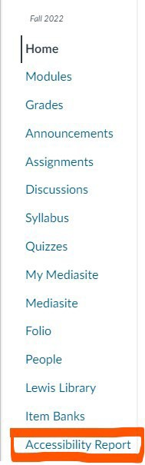
Ally is an accessibility tool that detects accessibility issues within your Canvas course. Ally scans the content and provides an accessibility score, identifies the issue and provides information on how to remediate the issue.
Ally is identified on your navigation bar as Accessibility Report link. Accessibility Report
When you click on Accessibility Report, the next screen you see is the Ally Accessibility Report.
You will see your overall course accessibility score at the top. Accessibility scores are color coded to indicate pass (green), needs improvement (orange), or fail (red). The most urgent items to address are those that are flagged red. A percent score is also provided to indicate how close to 100% accessible is the content. 85% indicates that overall, this course is pretty close to 100% accessible. With additional remediation of content, the score will continue to improve.

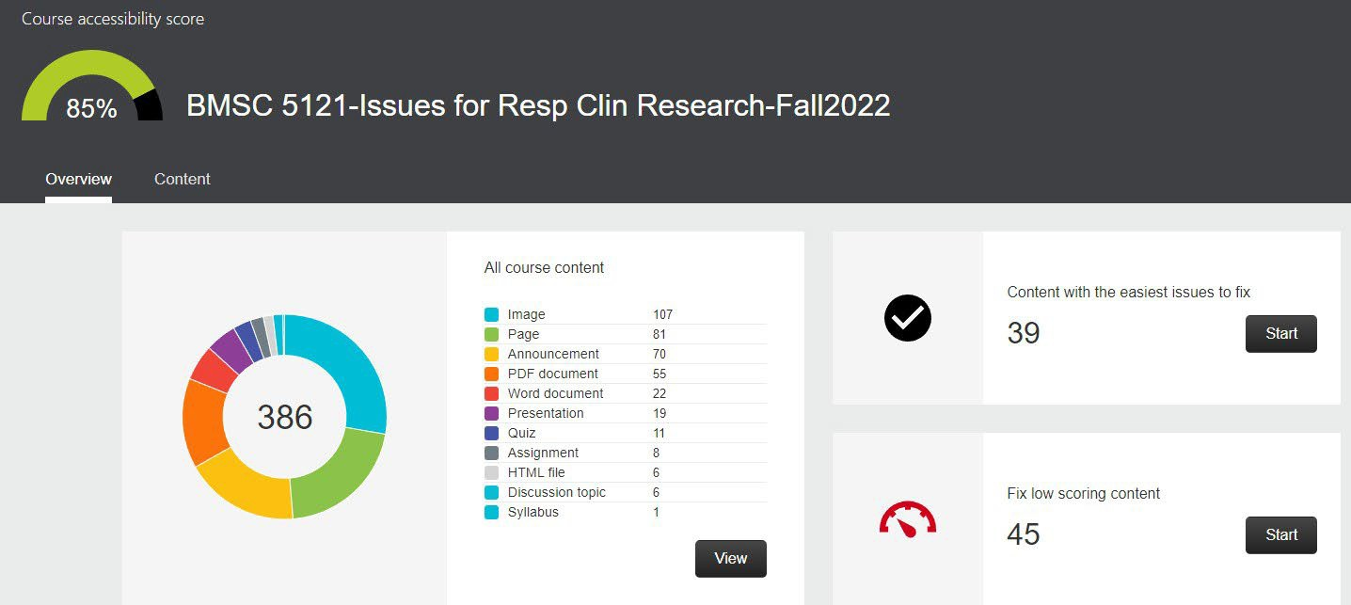
Your Course Title Appears Here

Next you will note two areas. If your course content has low scores or flagged in red, these are the items that will need to be addressed first. To begin reviewing the content, click on Start button.
You will then see a list of the content, the type of content it is, and its score. Click on the specific item to open it. Then you will see the problem Ally identified, an explanation, and how to fix it.

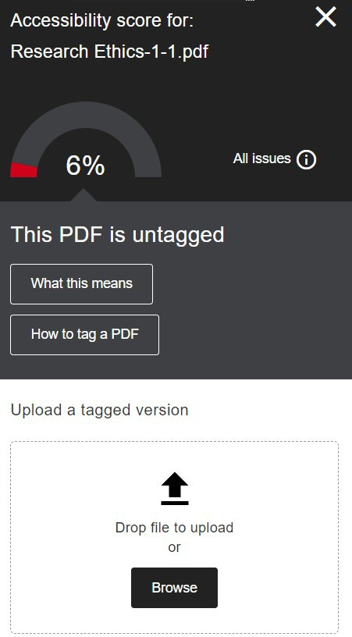
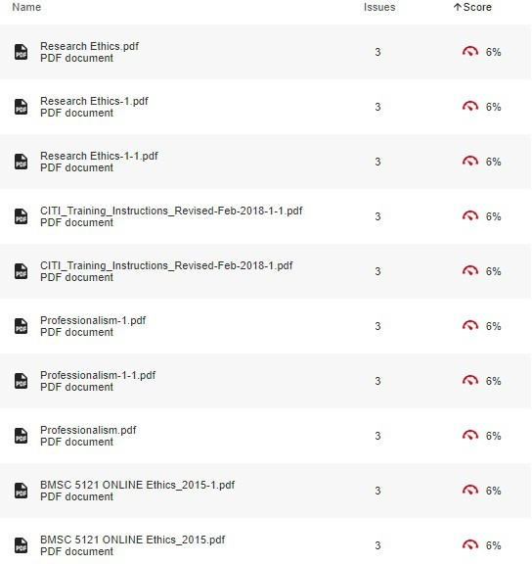
Generally, you only have two types of content: HTML or Files.
HTML issues can be remediated right in the Ally tool. These type of issues are typically missing descriptions on images, or issues with color contrast in Canvas.

File issues have to be fixed offline, meaning the file has to be fixed or remediated in the original program it was created. So PowerPoint presentations, Word, PDF, or other file types will have to be fixed in its own program. Each of these programs have their own Accessibility Checker. Use the checker in each to fix the issues. When you have finished editing your file, reupload it to Canvas either using the Ally tool or replace the file using Files on the Canvas navigation bar. Ally will scan the reuploaded file and provide a new score.
List of most common accessibility issues found by Ally: HTML:
- HTML content has contrast issues
- Image has contrast issues
- Image is missing a description
- HTML content has videos without captions
- HTML content contains links without discernible text
- HTML content has tables that don’t have any headers

Files:
- Document has contrast issues
- Document contains images without a description
- Document has tables that don’t have any headers
- Document does not have any headings
- Document is missing a title
- Document does not have a language set
- Document is untagged
- Document is scanned but not OCRed

