Creating Accessible Microsoft Excel Documents

Updated 3/2026

From Excel Support

Name Worksheets

When creating a new Excel document or workbook, by default worksheets are named Sheet1, Sheet2, etc. Rename the worksheets using unique descriptive names to make it easier to navigate a workbook. To rename a worksheet, right-click on the sheet tab, choose Rename and type the new name. Or use the shortcut keys Alt + H > O > R, then type the new name.

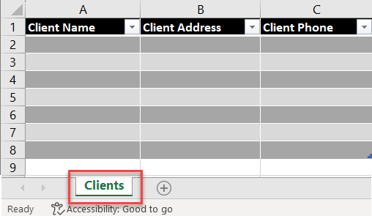
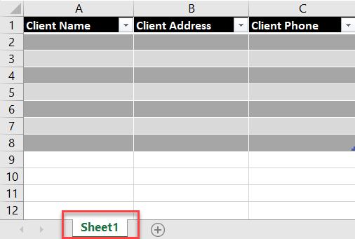

Name Tables

When you create a table, by default, Excel names tables Table1, Table2, etc. Give tables a meaningful table name. On the Table Design tab, under Table Name, replace the default name.

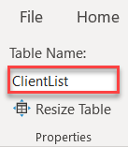
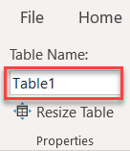

Select an accessible table style

Make a table more accessible by choosing colors with a strong contrast. For example, alternate between white and a dark color, such as black, dark grey, or dark blue. On the Table Design tab, in the Table Styles group, select a style with a strong contrast.

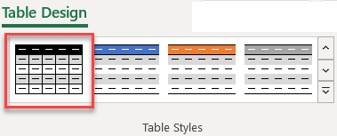

Use Table Headers

Using table headers to identify rows and columns provides clarity in context and makes navigating the table content easier. Under Table Design, in the Table Style Options group, select the Header Row checkbox. Then type in the column headings.
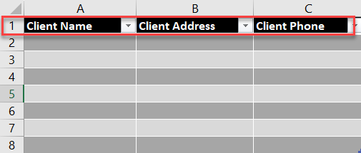
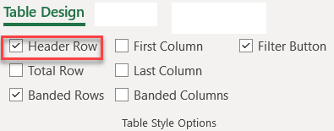

Run the Accessibility Checker
The Accessibility Checker in Excel is a tool that reviews your content and flags accessibility issues. The issues are explained and suggestions are provided to resolve them. To launch it, select Review > Accessibility Checker. The Accessibility pane will open on the right. You can now review and fix the issues found.

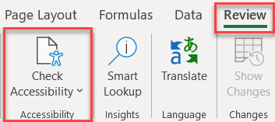

For more information on making Excel spreadsheets more accessible, go to Make your Excel documents accessible to people with disabilities on the Microsoft Support website.

Created by UNT Health Division of Academic Innovation
Last updated 3/2026

