Creating Accessible Fillable PDF Forms in Acrobat
Updated 3/2026

If you already have a form, run it through the Prepare Form tool in Acrobat.
Choose the file you want Acrobat to scan. This will identify the fillable fields.

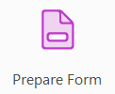

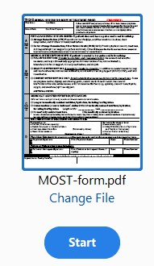

The Prepare Form tool identifies and labels fillable fields. Any of the blue fields can be edited or deleted if not needed. This tool predicts where it thinks a fillable field is needed. In the example below, 4 unique fields are needed, not 2. Double click on the blue fillable field to edit the label. You can shrink the size to fit as needed.

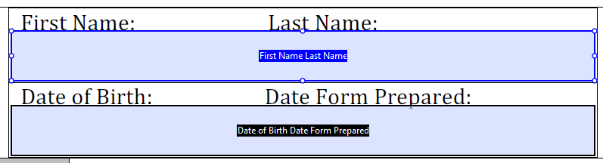

Add Text Fields by using the Text Field icon on the tool bar.

Make sure that the Name and Tooltip in the Text Field Properties window are the same.
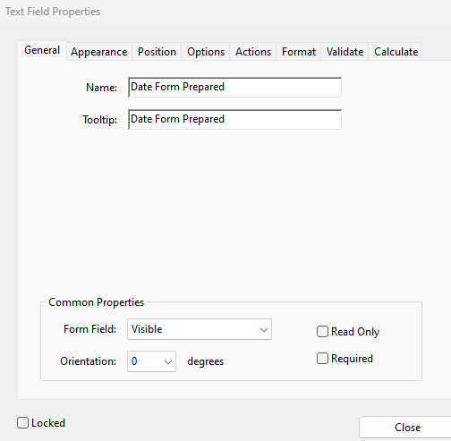

The above fillable fields should look like this:

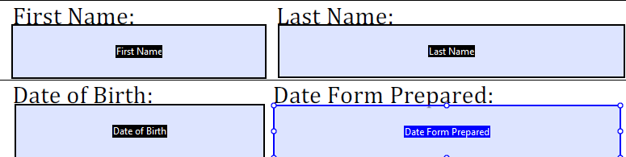

The Prepare Form tool will also add where it thinks checkboxes are needed. You can also edit or delete these as needed.

The list of all the fields, checkboxes, etc appear in the right pane. As you add new fillable fields or checkboxes, you have to rearrange the order. All the newer elements are added at the end of this list. Fix this by dragging and dropping the field/checkbox in the order they are to be filled out.

For instance, since Last Name field was added, you will need to drag and drop it from the end of the list to just below First Name field.

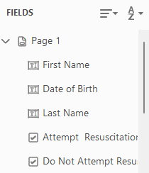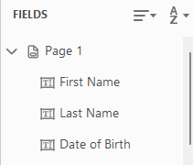

Once you have all the elements in correct order, save the new document.

For more tips, go to Accessible Forms in Acrobat

For more detailed information, watch a video here. Create Accessible PDF Forms video

3/2026 VJS

