Creating Accessible Microsoft Word Documents

Structure your document by using Headings in Styles.

Using headings in your Word document makes it easier for screen readers to scan through the contents of a document.

Organize your headings by heading levels (Heading 1, Heading 2, …). Keep it simple, use no more than three heading levels if possible. You can also use title and subtitle if the document is very simple.

Home > Styles (Alt + H + L)

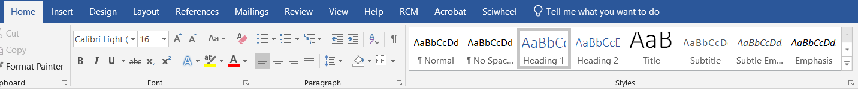

Make sure all images/graphics have descriptions by adding alt-text.

Alt-text, or descriptions, help people who can’t see the screen understand what is important in the visual content. In alt-text, you want to briefly describe the image and its intent. Avoid using text in images as the sole method of conveying important information. Example: infographics. Make it a point of the repeating this text in the body of the document.

To add alt-text to your image, do either of the following:
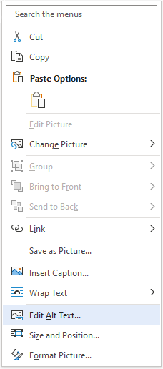
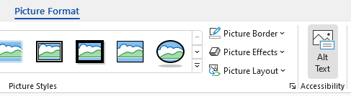
- Select the object and then select the format menu for the object, for example, Picture Format. Select Alt Text.

OR
- Right-click the object and select Edit Alt Text.
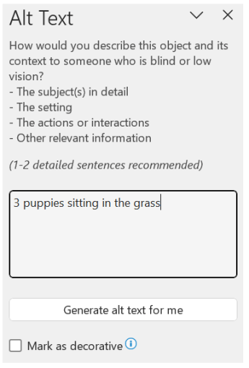
Then in the Alt Text pane, type 1-2 sentences in the text box to describe the object and its context to someone who cannot see it.
If your visual is purely decorative or should not have a description, check the box Mark as decorative. People using screen readers will hear that the image is decorative so they know they aren’t missing important information.

Use the following table guidelines for accessibility.

In general, use tables only to present data. Do not use a table in place of a list. Basic guidelines:

- Do not include the title of the table within the table itself. Make sure it is outside the table.
- Avoid using fixed width tables.
- Do not merge any cells within a table.
- Make sure the tables render properly on all device types: phones, tablets.
- Make sure tables have a header row (and header column if applicable). In your table, place your cursor on the header row. Then in Table Tools > Design, make sure Header Row box is checked. Then in Table Tools > Layout, keep your cursor on the header row and turn on Repeat Header Rows.

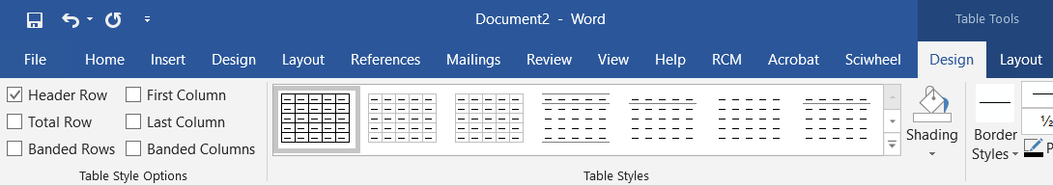

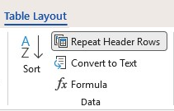

Accessible hyperlink text.
All hyperlinks should convey clear and accurate information about the destination. Avoid using “click here,” “see this page,” “go here,” “learn more,” etc. Instead use the full title of the destination page.
- Insert the link you want to work with into a Word document and turn it into a hyperlink.
- Select the whole URL, including the "http" at the beginning and the domain at the end.
- Right-click to open the context menu, then find and select Edit Hyperlink.
- In the dialog box, look for a text box labeled Text to display. Type in the description text you want.
- Click OK.
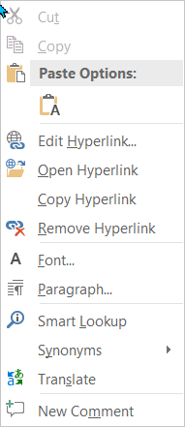
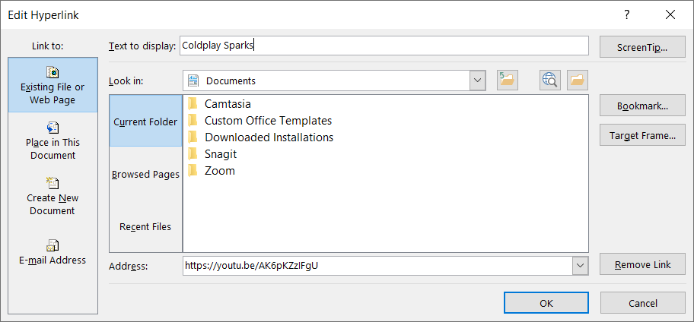

Run the Accessibility Checker under the Review tab for additional suggestions for improvement.
The Accessibility Checker in Word is a tool that reviews your content and flags accessibility issues. The issues are explained and suggestions are provided to resolve them. To launch it, select Review > Accessibility Checker. The Accessibility pane will open on the right. You can now review and fix the issues found.
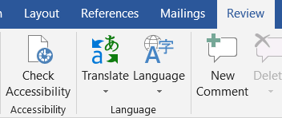

For more information and guidance with accessibility for Word documents, go to the Microsoft support link below.
Make your Word documents accessible

Created by UNTHSC Division of Academic Innovation
Last updated 3/2026

