Create Accessible PDFs using Acrobat
Updated 3/2026
- Open the Prepare for accessibility icon under Tools in Acrobat. This will open a new list of menu items. The two most valuable features are:

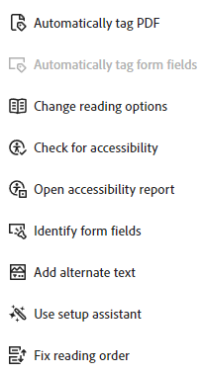
  - Automatically tag PDF. This automatically adds tags to your document for improved accessibility.
  - Add Alternate Text to add a brief description to an image if needed, otherwise check the “Decorative figure” checkbox if no description is needed.

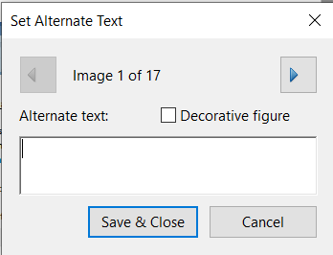

- Under the Menu tab, go to Document Properties.

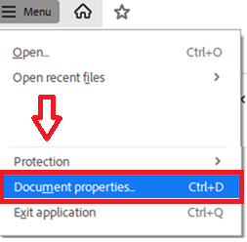
Make sure to do the following in each of the tabs:

  - Description tab: add title of the document in the Title box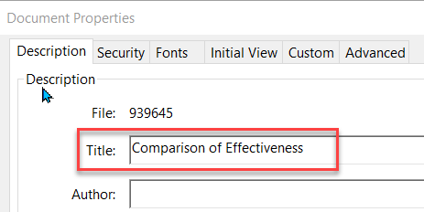

  - Initial View tab: under Window Options, Show: Document Title, not File Name
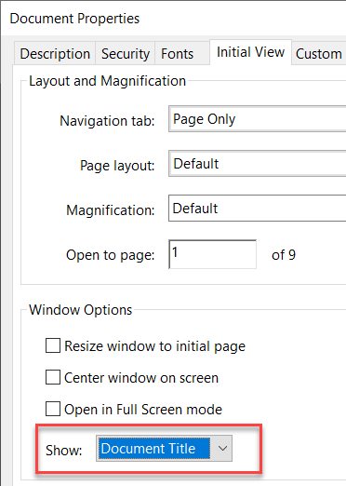

  - Advanced tab: under Reading Options, set Language: English
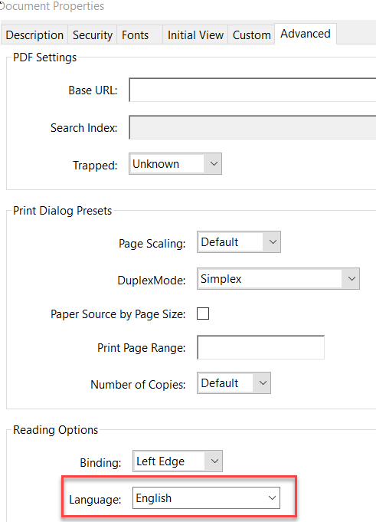

Fixing these items will yield a pretty good accessibility score. However, if you wish to investigate more accessibility issues with your document, run the Accessibility Check option on the Accessibility menu to get an accessibility report.
To get more information on creating accessible PDFs, go to the link below.
Here Is a video on how to tweak the tags in a PDF for more accessibility.
Creating Accessible PDFs video

Created by UNTHSC Division of Academic Innovation
Last updated 3/2026

