Creating Accessible PowerPoint Presentations
- Add alt text to an object/image

Select the object/image, right click, then from the menu select Edit Alt Text. You can also select Format on the Ribbon, then Alt Text, as shown below.
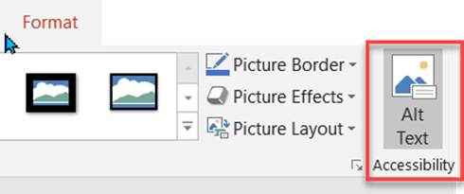

The Alt Text pane opens on the right of the document. Add a description in the box. You can also let PowerPoint generate a description for you then edit as needed. If the image is only decorative or does not need a description, then check the "Mark as decorative" box.
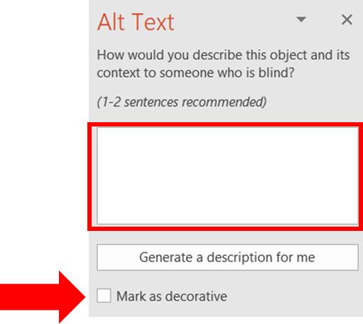

- Add Notes to Slides
To further improve accessibility of your PowerPoint slides, add Notes to the slides. Click on View, then Notes to open the Notes pane below the slide. Use this area to add lecture notes, or information from images or infographics that cannot be read by a screen or text reader.

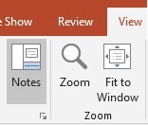
- Create accessible hyperlinks
When using hyperlinks, use clear and accurate information about the destination. Avoid using "click here," "go here," learn more," etc. Instead use the full title of the destination page or descriptive name. 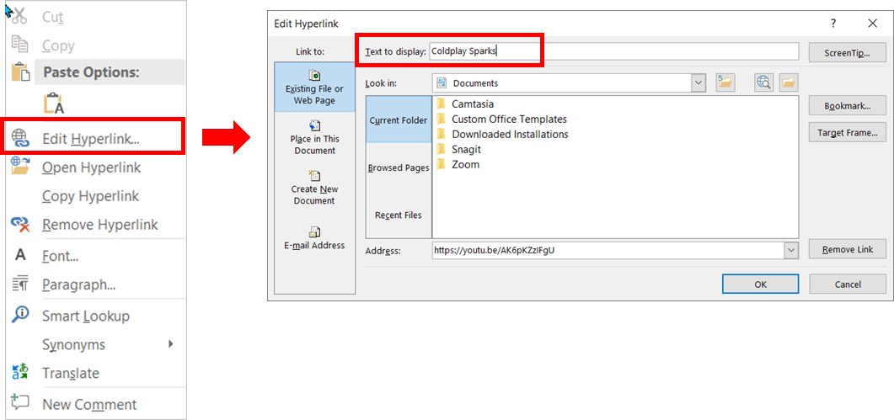

4. Add Slide Titles
Add slide titles to each slide. This helps navigate the PowerPoint in the Outline View. To see if your slides have slide titles, go to View and choose Outline View. You can also run the Accessibility Checker under the Review tab to find which slides are missing slide titles. The Accessibility Checker will give 3 options on missing slide titles: Set as Slide Title (for existing text on the slide), Add Slide Title, or Add Hidden Slide Title. A hidden slide title can be used when the whole slide is a graphic or a video and you don't want the slide title to appear on the slide.

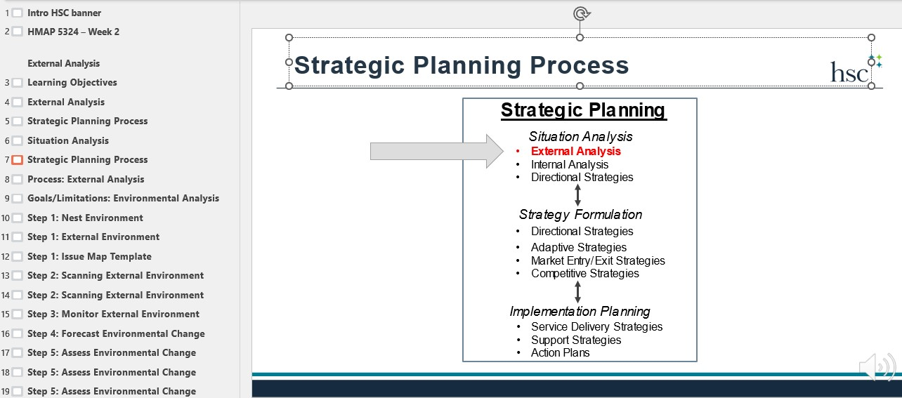
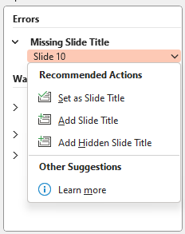

5. Table guidelines:

- Do not include the title of the table within the table itself. Make sure it is outside the table.
- Avoid using fixed width tables.
- Do not merge any cells within a table.
- Make sure the tables render properly on all device types: phones, tablets.
- Make sure tables have a header row (and header column if applicable). In your table, place your cursor on the header row. Then in Table Tools > Design, make sure Header Row box is checked. Then in Table Tools > Layout, keep your cursor on the header row and turn on Repeat Header Rows.


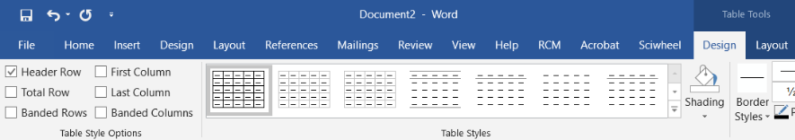

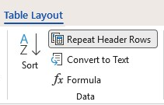

6. Video and Audio content must be captioned.

7. Run the Accessibility Checker
Run the Accessibility Checker under the Review tab to find other issues and further improve accessibility of your PowerPoint slides.

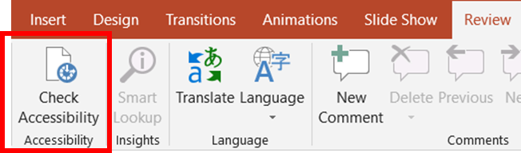

For more information and guidance with accessibility for PowerPoint presentations, go to the Microsoft support link below.
Make your PowerPoint presentations accessible
Created by UNTHSC Division of Academic Innovation
Last updated 3/2026

