Making Scanned PDFs Accessible Using Acrobat

Scanned PDFs are inaccessible. This means that the text cannot be read by a screen reader because it is an image. To make the PDFs accessible, run the OCR (Optical Character Recognition) feature in Acrobat.

- Open the PDF in Acrobat.
- Under Tools, locate the Scan & OCR icon under the Create & Edit category.
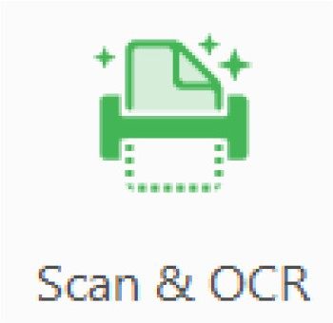

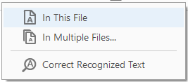

- When the Scan & OCR bar opens, select Recognize Text > In This File > Recognize Text.
1
3
2

The result will be a PDF that is no longer an image, but a text-based document. The accuracy of the text recognition depends on the clarity of the original image.

Created by UNT Health Division of Academic Innovation Last updated 3/2026

