UDOIT Cloud Help Sheet

UDOIT (Universal Design Online content Inspection Tool) scans your course for accessibility issues and assists you in correcting these issues generally within the UDOIT Cloud.
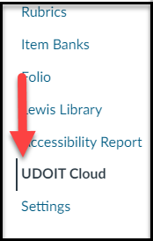
- UDOIT Cloud is automatically enabled in all Canvas courses and appears in the Course Navigation.
  - The UDOIT Cloud tool automatically updates.
  - Only instructors and staff can see the UDOIT Cloud tool, not students.
- When you click on the UDOIT Cloud in the course menu, you may be asked to authorize it. This should only need to be done once.
- Once authorized UDOIT will show the Welcome screen and automatically scan the course. The scan may take 1-2 minutes based on course content.

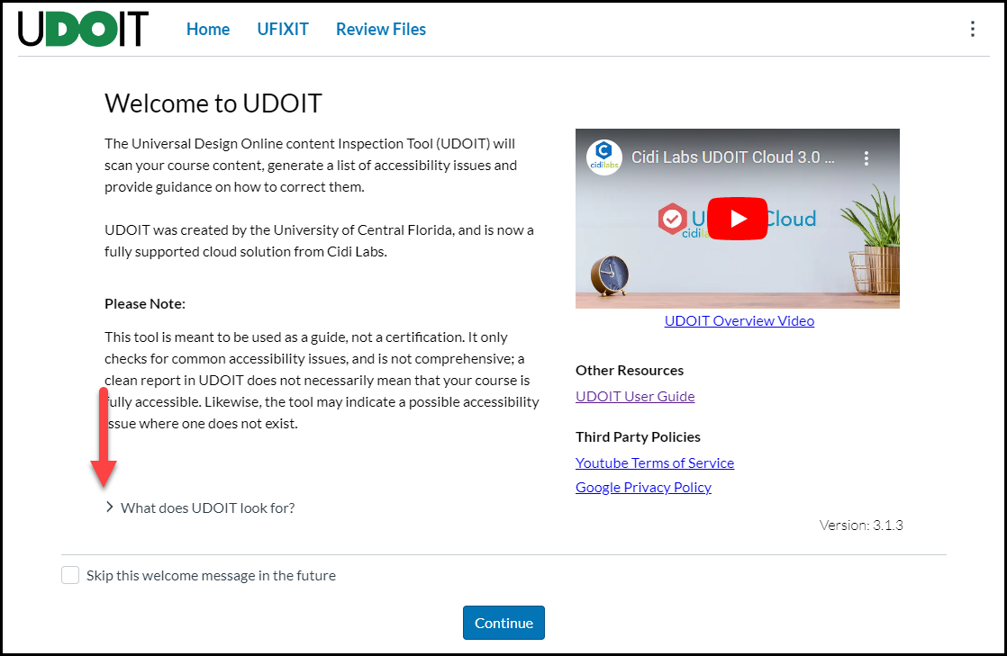

- The Welcome screen provides an overview of the tool including:
  - Overview Video
  - UDOIT user guide
  - What does UDOIT look for?
    - Click on the arrow to view the various errors and suggestions
      - Provides information as well as possible links for additional information
    - To view the welcome screen at any time, click the three dots at the top of the dash, then

About.

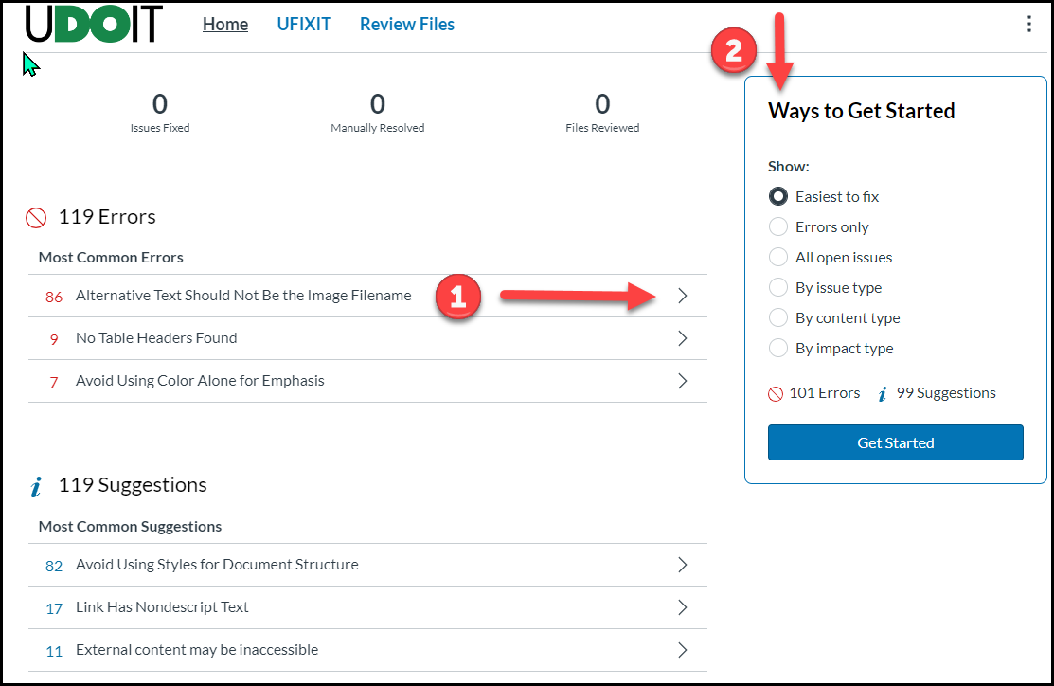
- Once the scan is complete, click on Continue to see the results of the course scan.
  - This displays the main UDOIT dashboard.
  - The top 3 errors and top 3 suggestions are displayed
  - Ways to improve accessibility in the course
    - Start with the first error, click arrow on the right to make corrections. (1 above)
    - Follow the suggestions of Ways to Get Started on the upper right. (2 above)
      - Easiest to fix: i.e. alt text, contrast issues
      - Errors only: most important to update
        - The difference between errors and suggestions is the suggestions may be content specific and may take more time to update.
      - All open issues:
        - Lists EVERYTHING
        - Can be overwhelming
      - By issue type:
        - Specific issues
        - Captioning
        - Alt text
      - By content type:
        - Announcements
        - Pages
        - Quizzes
        - Syllabus
        - By using this filter, an instructor can focus on the most relevant student areas.,
      - By impact type (relevant to accessibility)
        - Visual
        - Auditory
        - Cognitive
        - Motor
- Correcting specific issues
  - Links Should Contain Text:
    - Check box “Delete this link completely instead”

    - Best practices suggest to not add an external link to an image.
  - Insufficient Text Color Contrast with the Background
    - Click the up arrow to increase contrast ratio. When the box turns green, contrast is accessible.
    - Click the Color Picker and select a more accessible color.
  - Image Elements Should Have an “alt” Attribute
    - Cannot use the image’s file name.
    - For complex images, best practices suggest including a description (up to 125 words).
  - No Table Headers found
    - Select Column Header, Row Header, or both
  - Closed Captions Were Auto-Generated
    - UDOIT can scan YouTube and Vimeo videos
      - UDOIT does not currently scan Mediasite videos
    - Adding or editing captions needs to be completed outside of UDOIT.
  - Captions were not found
    - If the video has captions, you may click Mark as resolved.
  - Link has non-descript text (under Suggestions)
    - Add text for the link
    - Check “Delete this link complete instead”:
- UDOIT scans the HTML in Canvas, but does not currently scan files (coming soon!)
  - PDFs and other files (i.e. Microsoft Office) are listed for your review but changes need to be made outside of UDOIT and reuploaded.
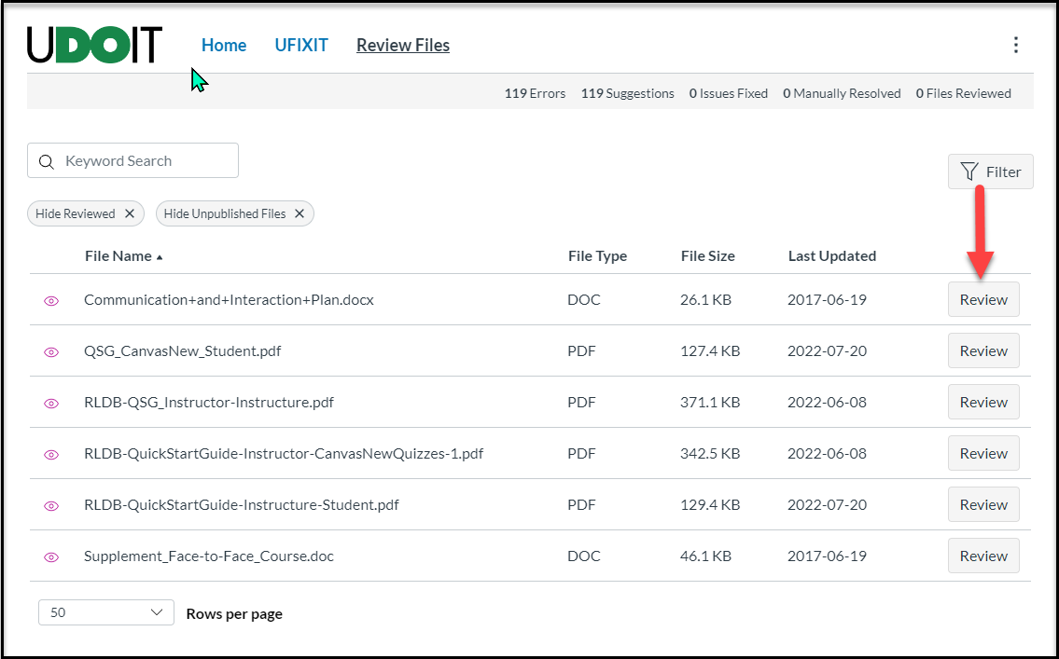

- Three dots (upper right corner)
  - Reports
    - Issues
    - Resolutions
    - Issues by type
For additional assistance with the UDOIT Cloud tool, contact canvas@unthsc.edu.
Developed by the Department of Educational Development, Division of Academic Innovation, 3/2026

